Unit: Children Around the World
Theme: People Around the World
Essential Question: How are we similar to and different from people around the world?
Focus Questions: What are globes and maps? What are people like around the world?

Vocabulary: globe, map, world, people, continent

Materials:
Paper, paper plate, or coffee filter
Blue & green crayons, markers, paint, or tissue paper
magazines
Crayons, scissors, glue, pencil
Playdough
Clothing cards (attached)
Matching game (attached)
Foam or wooden cone, cube, cylinder, and rectangular block
Letter A & X worksheets (attached)
Math Lesson 9 worksheet (see attached)
Clothespins
Index card or paper

Read Alouds to View:
We Are All Alike, We Are All Different by the Cheltenham Elementary School Kindergarteners https://www.youtube.com/watch?v=7h2sVeuDCiI
Whoever You Are by Mem Fox https://www.youtube.com/watch?v=W8BtVuY02VU
All Kinds of Children by Norma Simon https://www.youtube.com/watch?v=0kyFyixSzn8
Swift Walker A Continental Journey by Verlyn Tarlton https://www.youtube.com/watch?v=nSKTiP78-0c
Same, Same but Different by Jenny Sue Kostecki-Shaw https://www.youtube.com/watch?v=6ZSW3FbNEfo

What We Wear: Dressing Up Around the World by Maya Ajmera, Elise Hofer Derstine and Cynthia Pon https://www.youtube.com/watch?v=xqeco-F17YU

Questions/Discussion Ideas after Read Alouds:
* How are children in the world like you?
* How are you different?
* In what ways are you similar and different?

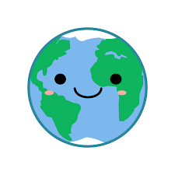

At Home Choice Board: Choose 2 activities to complete each school day!
Create a globe craft. Use a coffee filter, paper plate, or cut a circle from paper. Use blue & green crayons, paint, markers, or tissue paper to create land and oceans! | Create a collage of people from around the world. Discuss how all people look similar and different. They all need the same things. | Complete the math Lesson 9 worksheet (see attached) | Practice finding the faces on 3D shapes by pressing a foam or wooden cone, cube, cylinder, and rectangular block into playdough. | Learn about the letter A:  https://www.youtube.com/watch?v=gsb999VSvh8  https://www.youtube.com/watch?v=KGZFmW3uPJE  Practice writing the letter A (Slant left. Slant right. slide.)!
Practice spelling your name! Write each letter on a clothespin. Clip the letters in the correct order on a index card or craft stick as shown:  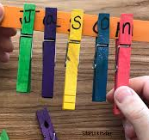 | Sing about the continents!  https://www.youtube.com/watch?v=kXa66f8Xgsw | Learn about the letter X:  https://www.youtube.com/watch?v=RX9Pm9qj_QY  https://www.youtube.com/watch?v=3AQUDbEhTm8  Practice writing the letter X (Slant right. Slant left.)! | Sing “What a Wonderful World”  https://www.youtube.com/watch?v=isMVH0ccQOY | Talk about what is shown on a map and a globe. How are they alike & different?  https://www.youtube.com/watch?v=ncR9lmC9VBg
Learn about 3D shapes:  https://www.youtube.com/watch?v=zPZegz690Mg | Enjoy a video:  https://www.youtube.com/watch?v=ni_at59TzMA&t=2s | Gingerbread Man Song:  https://www.youtube.com/watch?v=wCZ3dzFK6BI&list=PLquv48BmmeZ_V9pCpoKp9ztMp8AEYQGK3 | Play a matching game with the cards attached. | Take a look at the different cultural clothing & dress up the paper doll. Make it into a puppet!  https://www.youtube.com/watch?v=dFDz_GZUeP4
Unit: Children Around the World
Theme: Places Around the World
Essential Question: How are we similar to and different from people around the world?
Focus Question: What are places like around the world?

Vocabulary: landmark, world

Materials:
Letter Y & Z worksheets (attached)
Pencils
My World journal page (attached)
Family math newsletter (attached)
Math Lesson 1 & 5 worksheets (attached)
For slime: 1/2 cup glue, 1/2 teaspoon borax, 1 1/2 cups hot water, blue & green food coloring, glitter
Glue
Pennies
Read Alouds to View:
Homes Around the World by Clare Lewis https://www.youtube.com/watch?v=N8SY6UMbro0
Schools Around the World by Clare Lewis https://www.youtube.com/watch?v=gm6-lmkDOFk
Somewhere in the World by Gina Cascone & Bryony Williams Sheppard https://www.youtube.com/watch?v=QyQwTKN0Apw
The Smile that Went Around the World by Patrice Karst https://www.youtube.com/watch?v=nIsPaFFi4XA
Love the World by Todd Parr https://www.youtube.com/watch?v=9MjBPf

HQZ0Y

Questions/Discussion Ideas after Read Alouds:
* Listen to the stories. Discuss how all people live somewhere. Talk about how your homes are similar or different from ones you saw in the story.
* Talk about the schools you see in the story. Which look like your school?
* Discuss how all over the world, there are children that need homes, food, love, and clothing. Talk about how they may differ from you.
* Review your child’s full name, age, birthday, and address!

At Home Choice Board: Choose 2 activities to complete each school day!
Take a look at different types of houses in the world!  https://www.youtube.com/watch?v=gKmt36dJBrA | Check out how schools look around the world! Discuss what you see!  https://www.youtube.com/watch?v=at2gAjtsgtk | Draw a picture of a globe. Draw what you would see all over the world- people, homes, animals, etc.  Use the My World journal page. | Practice writing the letter Y- Slant right. Slant left. Pull down.. (see attached) | Learn about the letters Y & Z  https://www.youtube.com/watch?v=L8PdL8ydI28  https://www.youtube.com/watch?v=HysVxhemAe4
Make your own Earth slime!  https://www.naturalbeachliving.com/earth-day-slime-recipe-with-borax/ | Sing “It’s a Small World” and enjoy a Virtual Field Trip:  https://www.youtube.com/watch?v=I2Do309e4YU | Practice writing the letter Z- Slide. Slant left. Slide. (see attached) | See landmarks from all over the world! Can you build one from legos, blocks, or boxes at home?  https://www.youtube.com/watch?v=kDCXqaYWn-U | Go on a scavenger hunt in your house! Find something that is shaped like a cylinder, cone, cube, rectangular block, and sphere!
Work out to the letter sounds and get moving!  https://www.youtube.com/watch?v=gi1dwHp1ppU&t=2s | Practice showing the numbers 6 & 7:  https://www.youtube.com/watch?v=anYJvL9kZoU  https://www.youtube.com/watch?v=PfEqSjgW4tk | Complete the Lesson 5 math worksheet (see attached) | Complete math lesson 1 (see attached.).  Practice counting to 6 & 7. | Line up 6 & 7 pennies in different arrangements. Practice counting them.

Unit: Children Around the World
Theme: Celebrations Around the World
Essential Question: How are we similar to and different from people around the world?
Focus Question: How do people celebrate around the world?

Vocabulary: celebrate, tradition, holiday

Materials:
letter U worksheet (attached)
letter J worksheet (attached)
crayons
My Family Tradition journal page (attached)
Paper
Glue
Math “6 & 7 Puzzles” (attached)
Math Lesson 8 & 9 worksheets (attached)
Math Lesson 10 worksheet (attached)

Read Alouds to View:
Let's Celebrate! Special Days Around the World by Kate DePalma https://www.youtube.com/watch?v=dTLNHW3ZqE8
Binny's Diwali by Thrity Umrigar https://www.youtube.com/watch?v=Ne3cJCL2_YA
El Dia de los Muertos: A Bilingual Celebration by Bob Barner https://www.youtube.com/watch?v=rNHWnv3TRxA

My First Ramadan by Karen Katz https://www.youtube.com/watch?v=_0EWsn83TGk
Celebrations by Samantha Berger & Daniel Moreton https://www.youtube.com/watch?v=ljDRrsFiaxQ

Questions/Discussion Ideas after Read Alouds:
* What do people celebrate? What does your family celebrate?
* How do you celebrate? When do you dress up, use candles, see fireworks, or make a special food?

At Home Choice Board: Choose 2 activities to complete each school day!
Learn about the letters U!  https://www.youtube.com/watch?v=nPJRhEV-kF8  https://www.youtube.com/watch?v=IF59Xs60uRM | Draw a picture of a way your family celebrates a holiday!  Use the My Family Tradition journal page. | Learn how children celebrate birthdays around the world!  https://www.youtube.com/watch?v=7jrTgtX8q9k&t=63s | Practice writing the letter U.- curve forward (see attached)  Practice writing the letter J- curve back. slide.. (see attached) | Learn about some holidays around the world:  https://www.youtube.com/watch?v=3Sv0ac-W8Vc
Try a new recipe from a different country! Here are some ideas:  https://www.kids-cooking-activities.com/international-gourmet-recipes.html | Practice making different groups of 6 & 7, breaking them apart in different ways. Use the “6 & 7 Puzzles” | Learn about Burmese New Year:  https://www.youtube.com/watch?v=2p-2GdsGQUQ | Celebrate Africa with one of these crafts:  https://artsycraftsymom.com/african-crafts-for-kids/ | Practice counting to 6 & 7 in circular arrangements. Use the Lesson 8 & 9 worksheets.
After listening to the story, make a craft about Diwali:  https://theeducatorsspinonit.com/easy-diwali-crafts-for-kids/ | Learn about the letters J!  https://www.youtube.com/watch?v=8wNIYNyG37g  https://www.youtube.com/watch?v=6KXX6fCKWes | Try a fun song to get you moving!  https://www.youtube.com/watch?v=zFQWVN4xip0 | Complete Math Lesson 10 worksheet. Draw tally marks for the animals as you count them (see attached)! ! | After listening to the story, make a craft for Ramadan:  https://artsycraftsymom.com/10-ramadan-crafts-and-activities-for-kids/

Unit: Children Around the World
Theme: Christmas Around the World
Essential Question: How are we similar to and different from people around the world?
Focus Question: How do people celebrate Christmas around the world?

Vocabulary: Christmas, holiday, tradition, celebration, custom

Materials:
Wooden shoe craft (see attached)
Pinata craft: styrofoam cup, crayons, pencil, string/ribbon, candies, scissors, tissue paper, rubber band
Glue
2 different colored pieces of paper
scissors
Playdough
paper

Read Alouds to View:
Christmas Around the World https://www.youtube.com/watch?v=7R0eOt7O3Po
Hanna’s Christmas by Melissa Peterson https://www.youtube.com/watch?v=Bbg4KFxVbTk
An Aussie Night Before Christmas by Yvonne Morrison https://www.youtube.com/watch?v=lLlKVy62j3k
Santa is Coming to Australia by Emma Nash https://www.youtube.com/watch?v=HbZk5ntGiSY
The Night Before Christmas by Clement C. Moore https://www.youtube.com/watch?v=TsvvCme40_w

Questions/Discussion Ideas after Read Alouds:
* How does your family celebrate Christmas?
*How do other people celebrate?
*What traditions from other countries seem fun?

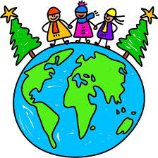

At Home Choice Board: Choose 2 activities to complete each school day!
Learn about Christmas in Brazil:  https://www.youtube.com/watch?v=IpPzQR77Qe8  Watch fireworks display from a past Christmas:  https://www.youtube.com/watch?v=rdYBv8ryYWk | Check out this website to learn about more customs:  https://www.whychristmas.com/  Here’s another video:  https://www.youtube.com/watch?v=kZy-JLb7noA | Learn about Christmas in Holland: https://www.youtube.com/watch?v=EQ1izMpi004  Make a wooden shoe craft (see attached) | Learn about Christmas in Mexico:  https://www.youtube.com/watch?v=rQnkdAExoyo  Make a pinata (see attached)  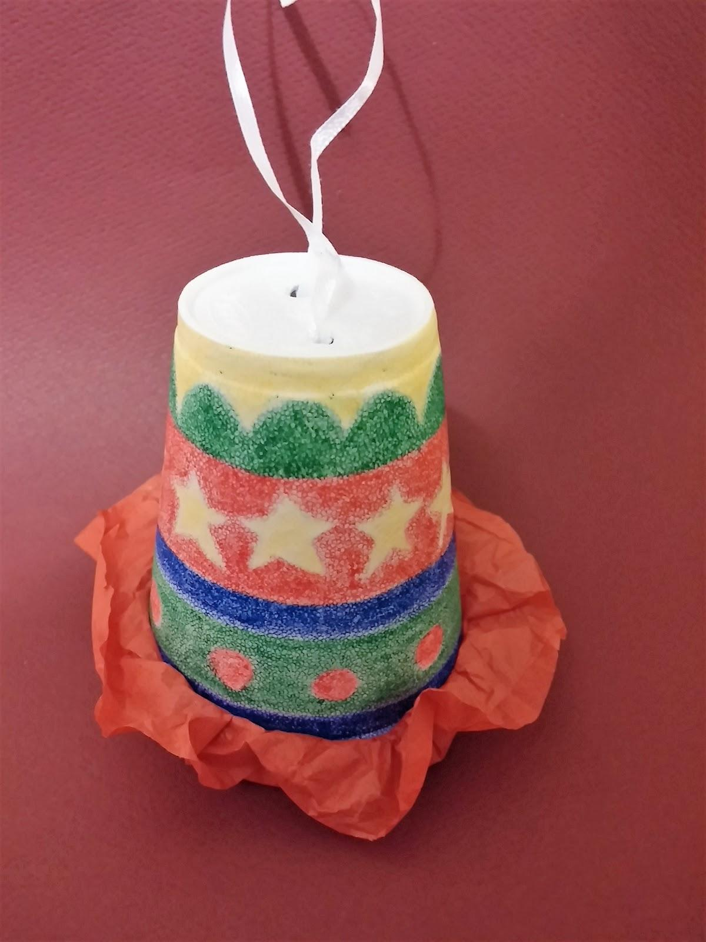 | Use playdough and cookie cutters to make Christmas cookies- or make some real ones!  Listen to Christmas carols as you do it!
Make a Christmas tree with the letters of your name!  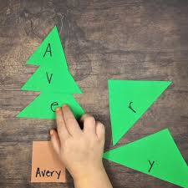  Draw and write about your family’s Christmas celebrations! | Learn about Christmas in Sweden:  https://www.youtube.com/watch?v=Bbg4KFxVbTk  Make a woven heart: | Practice the alphabet with this fun Christmas song:  https://www.youtube.com/watch?v=Pn9ZA9QPhNU | Learn about Christmas in France:  https://www.youtube.com/watch?v=1vwg3P0SFBI  Make a Yule Log (see attached):  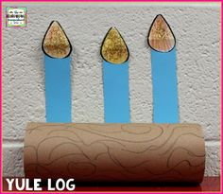 | Practice counting:  https://www.youtube.com/watch?v=38_a6IDxYw8

MY COMMUNITY READING LOG
Read a story EVERY DAY!! Draw a star or smiley face or place a sticker on the date when done!
November/December
29 | 30 | 1 | 2 | 3 | 4 | 5
6 | 7 | 8 | 9 | 10 | 11 | 12
13 | 14 | 15 | 16 | 17 | 18 | 19
20 | 21 | 22 | 23 | 24 | 25 | 26
27 | 28 | 29 | 30 | 31

Math Lessons:
***Click on the links below to see full lessons and activities to support the skills.**

Week 1:
https://www.engageny.org/resource/prekindergarten-mathematics-module-2-topic-c-lesson-9
https://www.engageny.org/resource/prekindergarten-mathematics-module-2-topic-c-lesson-10
https://www.engageny.org/resource/prekindergarten-mathematics-module-2-topic-c-lesson-11
https://www.engageny.org/resource/prekindergarten-mathematics-module-2-topic-c-lesson-12

Week 2:
https://www.engageny.org/resource/prekindergarten-mathematics-module-3-topic-a-lesson-1
https://www.engageny.org/resource/prekindergarten-mathematics-module-3-topic-a-lesson-2
https://www.engageny.org/resource/prekindergarten-mathematics-module-3-topic-a-lesson-3
https://www.engageny.org/resource/prekindergarten-mathematics-module-3-topic-a-lesson-4
https://www.engageny.org/resource/prekindergarten-mathematics-module-3-topic-a-lesson-5

Week 3:
https://www.engageny.org/resource/prekindergarten-mathematics-module-3-topic-b-lesson-6
https://www.engageny.org/resource/prekindergarten-mathematics-module-3-topic-b-lesson-7
https://www.engageny.org/resource/prekindergarten-mathematics-module-3-topic-b-lesson-8
https://www.engageny.org/resource/prekindergarten-mathematics-module-3-topic-b-lesson-9
https://www.engageny.org/resource/prekindergarten-mathematics-module-3-topic-b-lesson-10

Week 4:
https://www.engageny.org/resource/prekindergarten-mathematics-module-3-topic-b-lesson-11

